**Create a Data Frame with Missing Values (NA):**

**Use R to create a data frame containing some missing values (NA).**

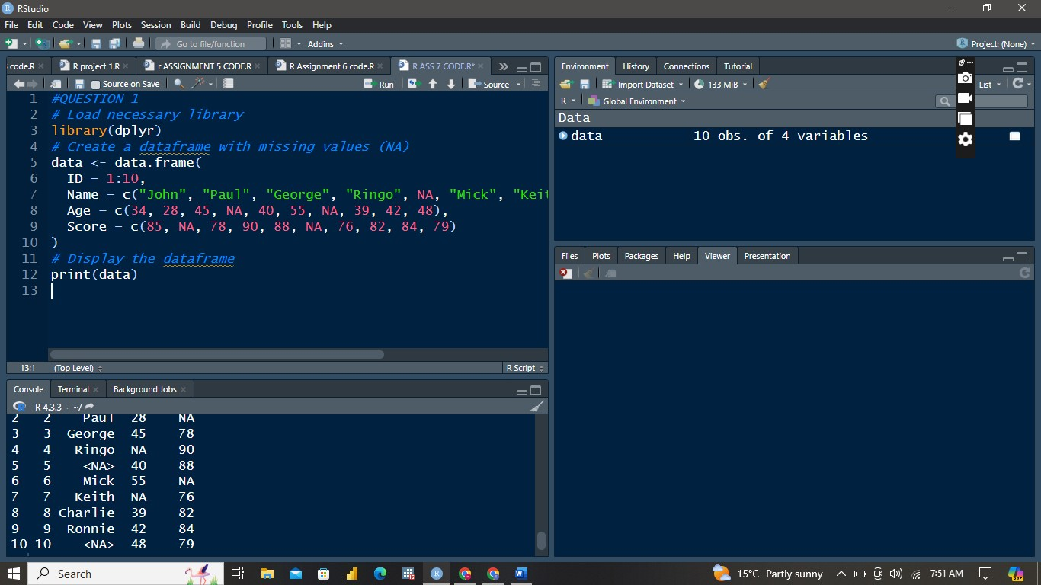

**Calculate Means and Sums:**

**Use the na.omit function to exclude NA values and calculate the**

**means and sums.**

**Use the na.rm parameter within functions to remove NA values and**

**calculate the means and sums.**

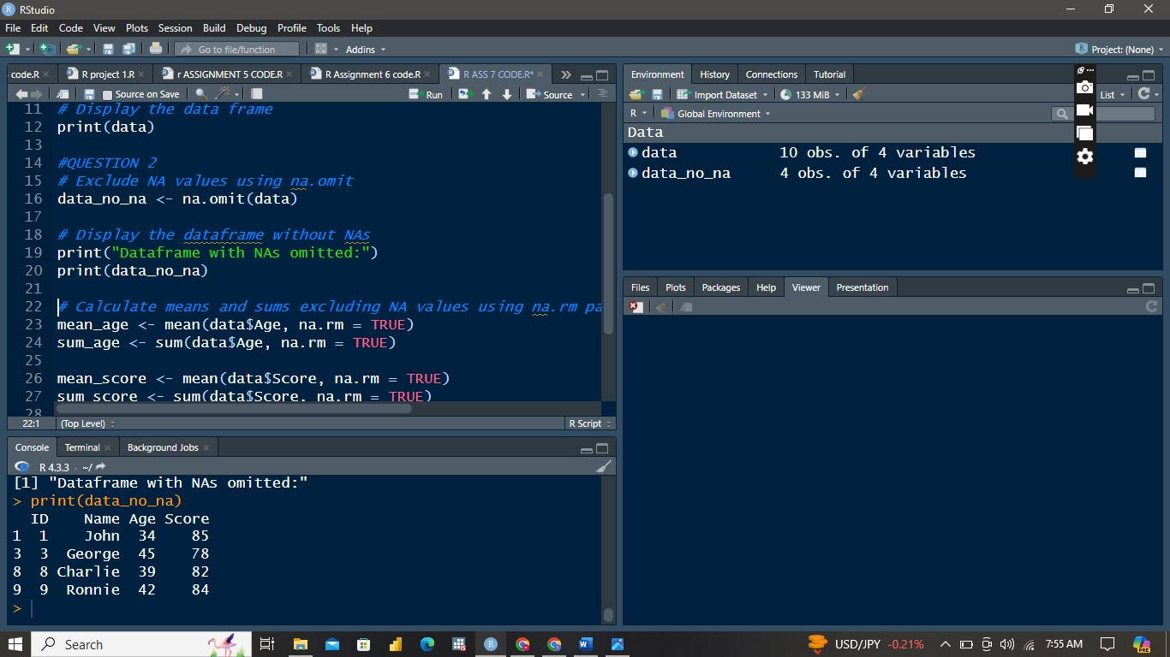

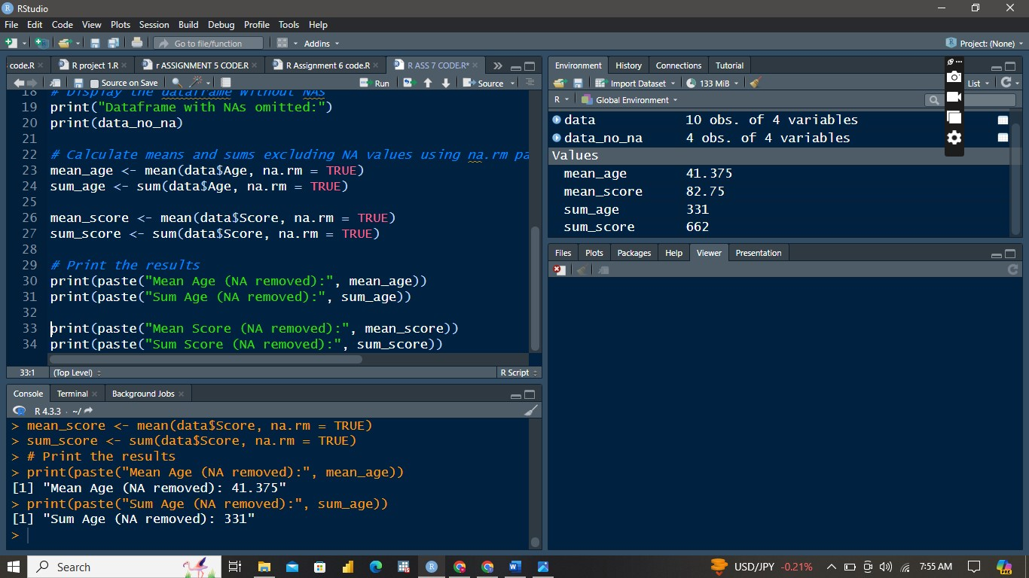

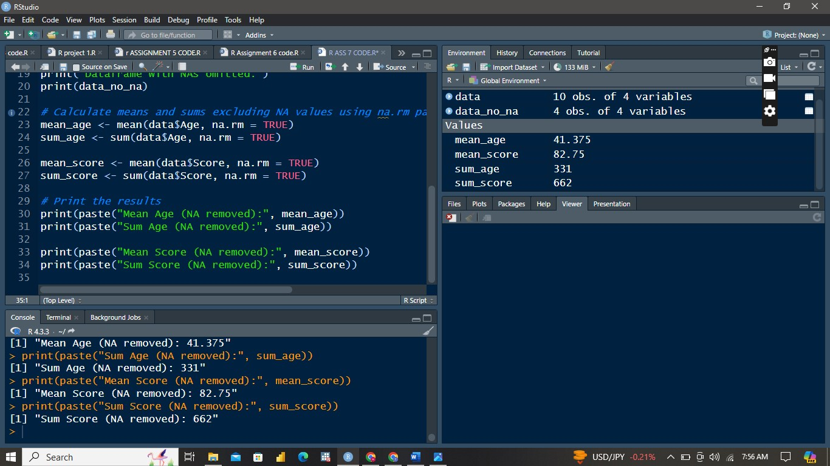

**Export the mtcars Dataset:**

**Export the mtcars dataset as an Excel file in .csv format.**

